CMIT 202 6385
PC Build and Manual Part III
October 11, 2018

Introduction: When building a computer there are many routes that can be taken depending on the users’ needs. Approximate date I need the computer? What is it going to be used for? How much will it cost? These questions will determine whether or not it is feasible for you to build your own PC or to purchase one from a store fully built.
Parts required minimally for PART III:
- (1) Fully Installed Personal Computer
- (1) Mouse utilizing USB
- (1) Keyboard utilizing USB
- (1) Monitor connected to the personal computer
Part 11 of 12: Installation of Windows 10
Windows 10, or the Operating System (OS), is the most crucial software that is on your computer. Its job is to identify what you want to do with the computer and translating it into the computing language. The OS communicates with the CPU, storage and memory. Windows is one of the 3 most popular OS, to include Mac and Linux as well.
There are many different ways to install an Operating System. You can do so with forms such as CD, DVD, or USB. You can also choose to install it via Networked media. Also, when you use USB, this is referred to as “bootable media”. This is when you create a bootable USB flash drive that has the installation on one drive. Microsoft helps assist in this process using a tool called the Windows 7/10 USB/DVD Download Tool.
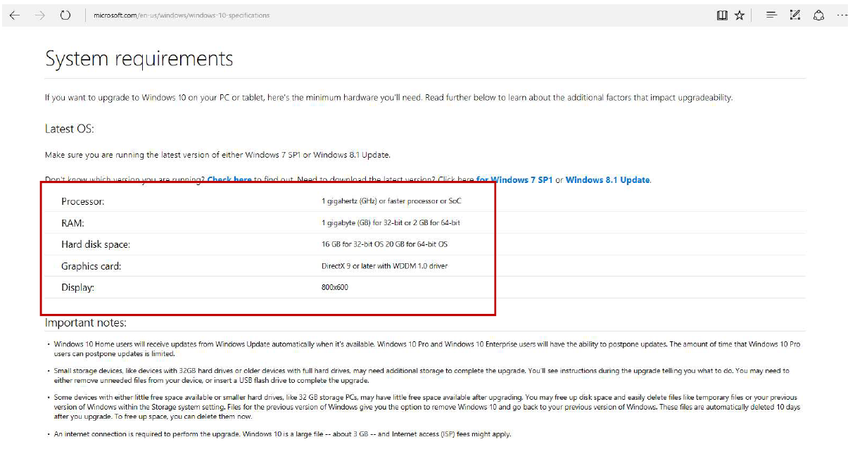
For this instruction, we will be installing Windows 10 Home Edition via an Installation Disc.
Windows 10 Home Edition Requirements
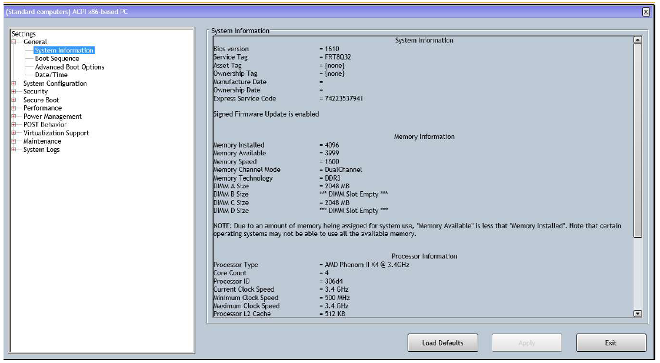
- Before we start, it is incredibly important to identify if your system is compatible with the Operating System you have chosen.
BIOS Home Screen

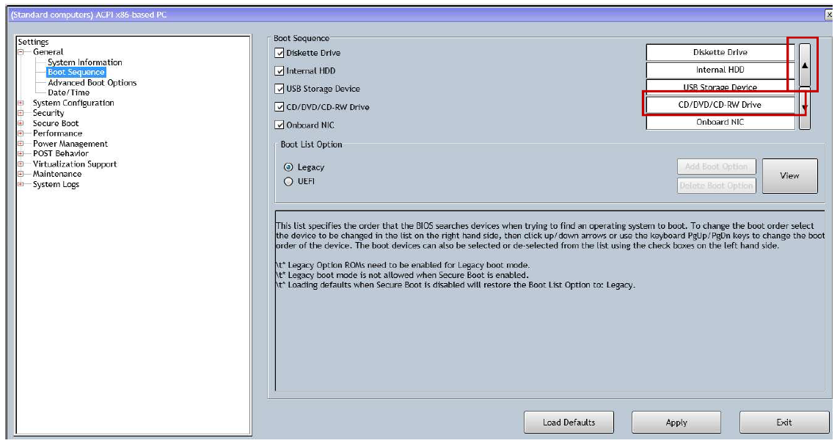
- Once you have identified your systems requirements, it is important to make sure all of the drivers are up to date. Next, we will identify the boot order or the “Boot Sequence”. To enter into BIOS you will need to start up the computer and upon startup press the “F2” key.
Boot Sequence
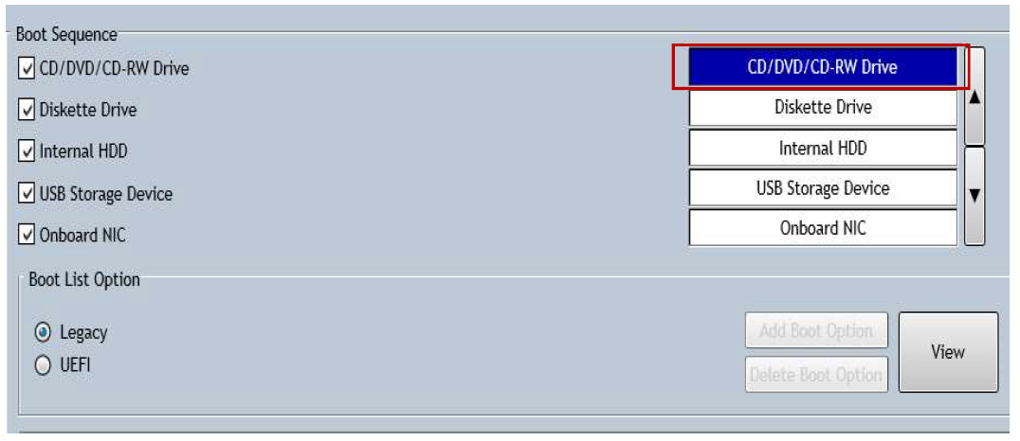
- (Continued) Boot Sequence identifies the process in which the system boots. Above indicates the following order: Diskette Drive, Internal HDD, USB, CD-DVD/CD-RW, and NIC. We will utilize the fourth in the list, which means it needs to be moved up. In order to move the fourth one, we will hit the arrow and move it to the first slot. Additionally, ensure the boot method is checked on the left side of the screen, if it is unchecked it will be disabled.
Changing Boot Sequence

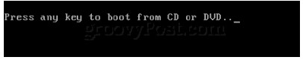

Prompt to Press Any Key

- Once you have completed all of the above steps the type of device you are using to install with will determine which route you take. The next step for this process of using a CD/DVD, Windows setup will prompt you to press any key to load the setup.

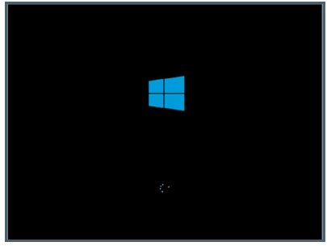

Windows Loading Setup Screen

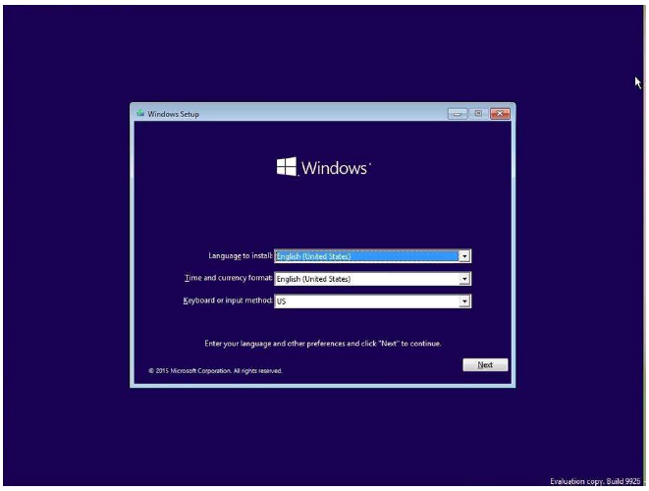
- (Continued) The windows Operating System should show the spinning dots as shown in the above image.
Windows Time, Language and Keyboard Method
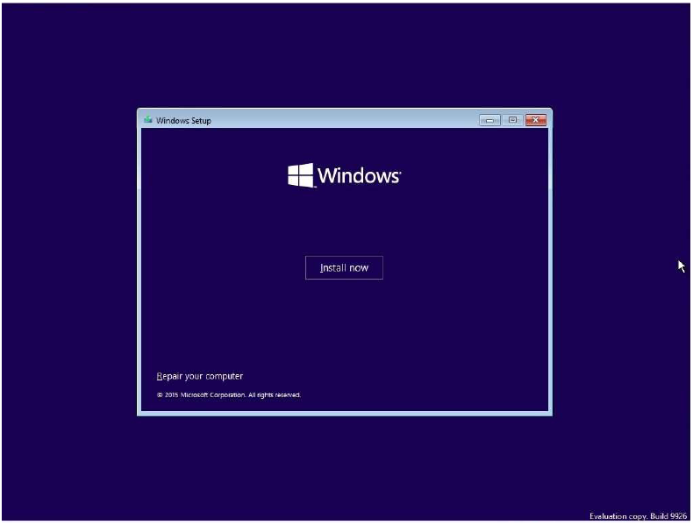
- Following this you will then be expected to select your Time, Language and Keyboard Method. Once doing so, hit next
Windows “Install Now” Screen
“

- (Continued) Hit the “Install Now”. This next section should take a while.

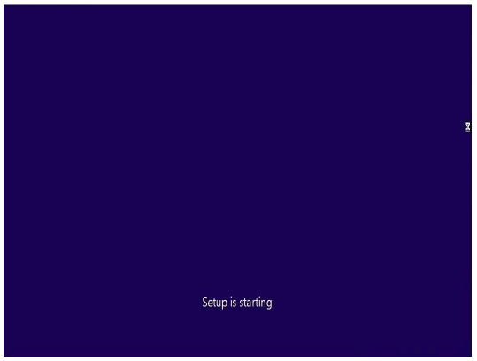
4. (Continued) This section should take a while.

Windows “Setup is starting“ Screen

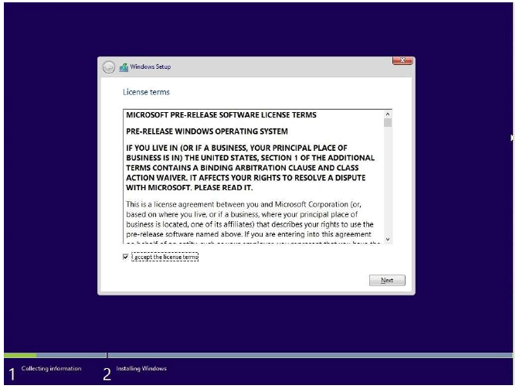
Windows License Terms and Agreements

- You are recommended to read the terms and agreements provided in order to use Microsoft’s software. Once you read and agree check the “I accept the license terms” and click next.
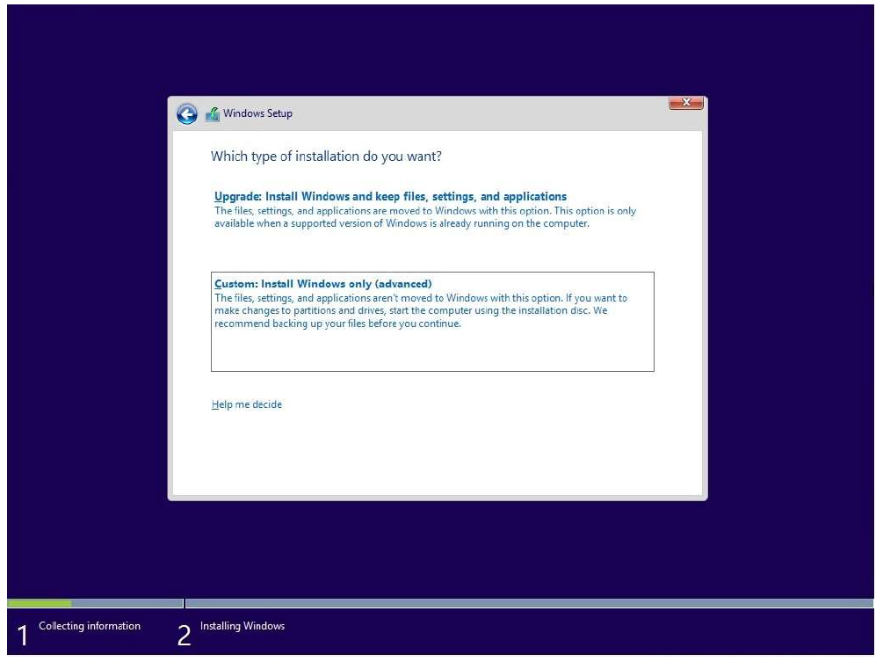

Windows Setup Installation Type

- When Windows asks you to select an installation type, select “Custom”.

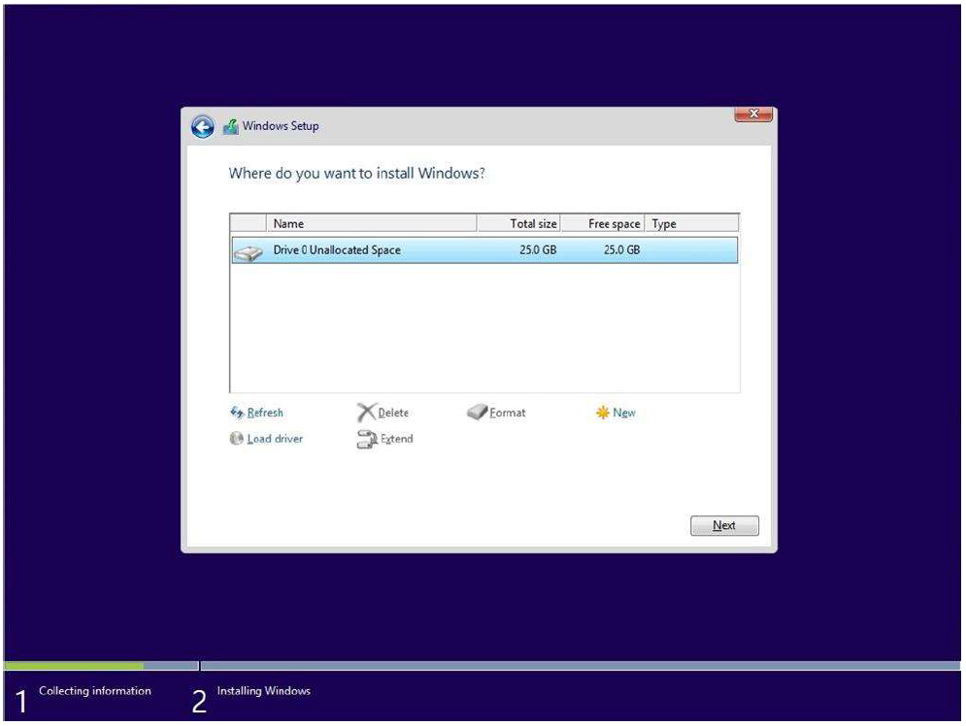

Windows Setup Drive
- Once you arrive at the screen replicating the one shown above you will select the media you saved the Windows files to. Next, you will want to click the unallocated space and click “apply”.

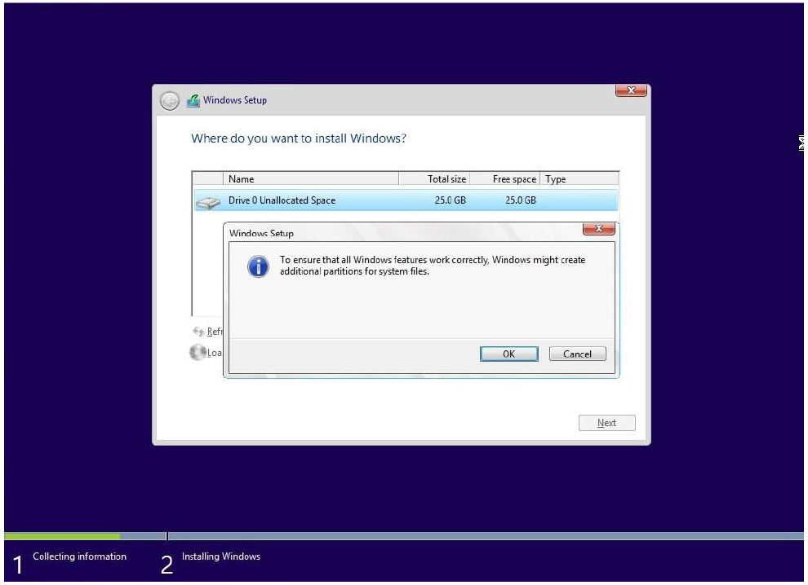
Windows Setup Drive
- (Continued) Click “Ok”.

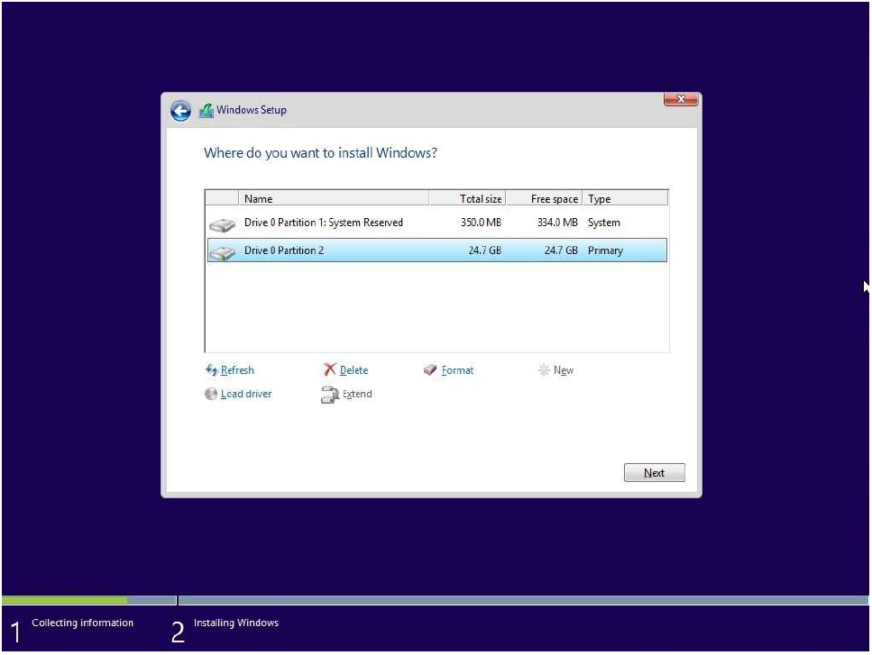
Windows Partition
- (Continued) Select the primary partition as shown above.

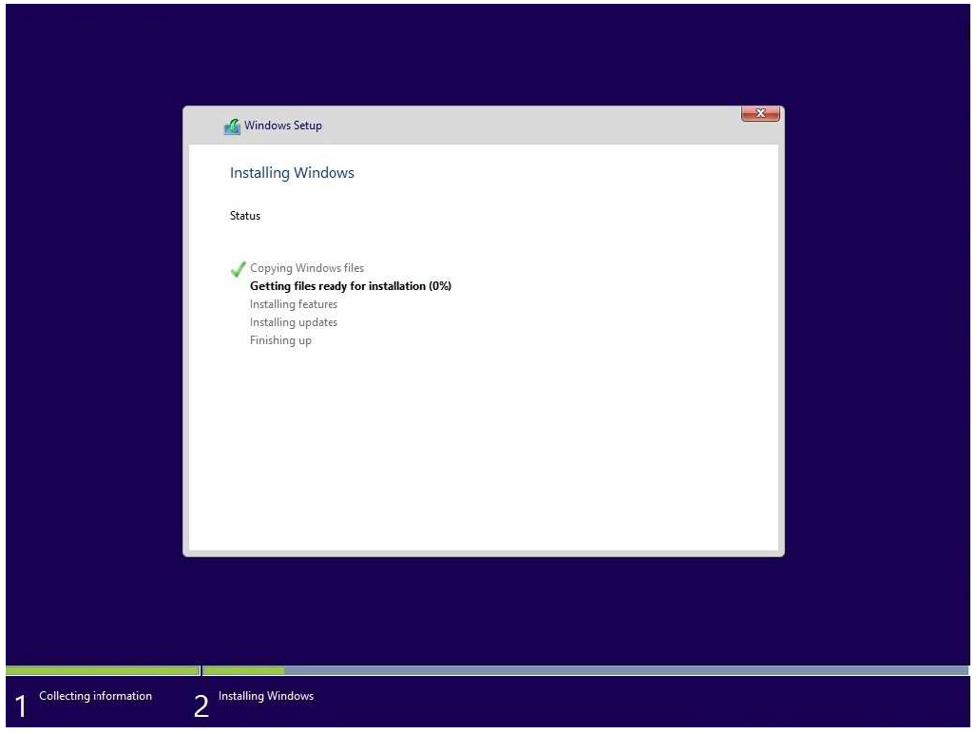
Windows Install Process
- The system should start to install Windows 10. Once finished, it will automatically reart and enter the process menu again.

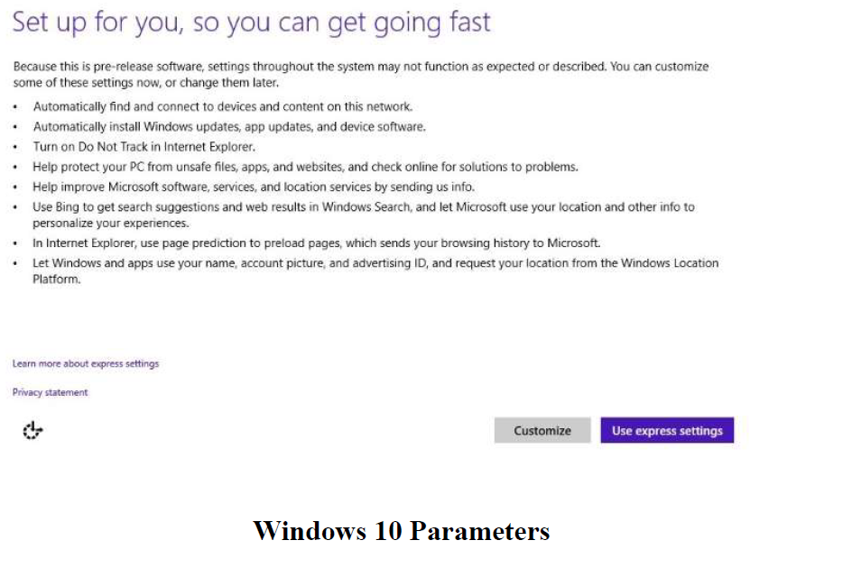
Windows Parameters

- Once restarted, you can either customize the parameters or choose to do a generic express setting.
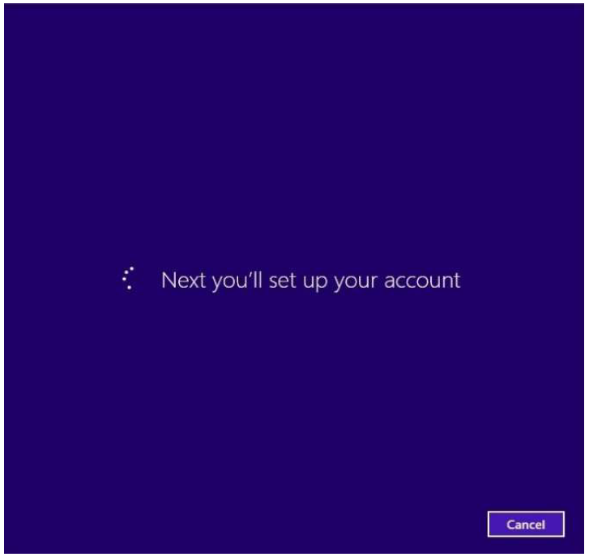
Windows Account Setup
- Install of Windows is now going to set up your account for the operating system
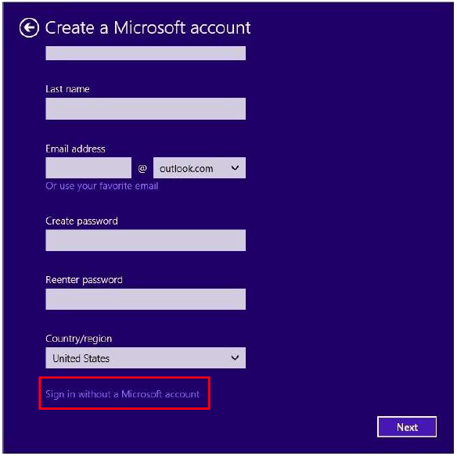
Windows Local Account Creation

- (Continued) You have a few options on this page. One, you can log in with an existing Microsoft email and sync the information, or, two, create an account for the local computer.

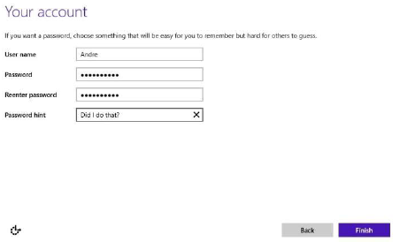

Windows Local Account Creation

- Name your account and set the password, once complete the system will load into the Operating System.

Part 12 of 12: Critical Windows Features
- After the installation of windows has finished there are a few more steps to ensure you have everything working properly. This is ultimately to help the security of the computer system.

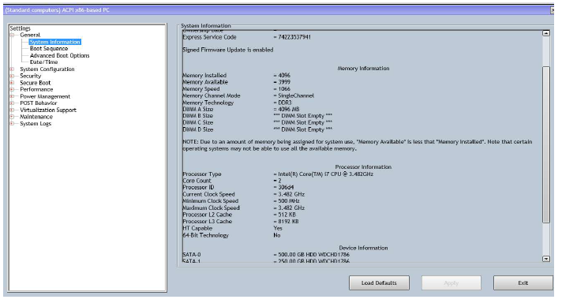
BIOS Setup Utility
- (Continued) When the computer goes to start up push the “F2” key to enter the BIOS. BIOS should look as above.
Boot Sequence
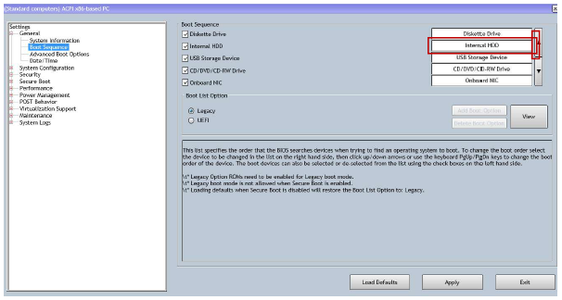

- (Continued) Once again, to alter the boot sequence identify which needs to be the first item to be booted from. For this instance, we will be selecting the Internal HDD. Select it and hit the arrows until it is first in line.
- Next, we will take a look at the drivers in order to identify which devices are unrecognized/recognized.
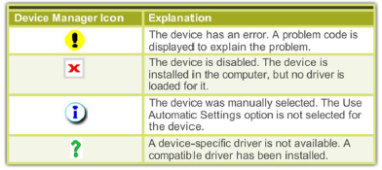

Device Manager Icons

- (Continued) In order to check the status of the drivers we will use the windows device manager. This is a utility that identifies the devices with icons.

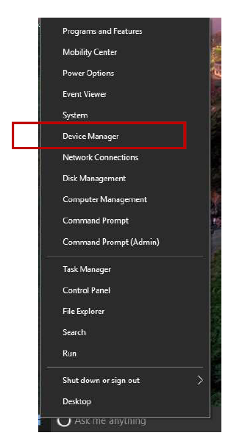

Right click on Start and select “Device Manager”

- Once windows has started up right click the “start” menu and select “Device Manager” as shown in the above image.

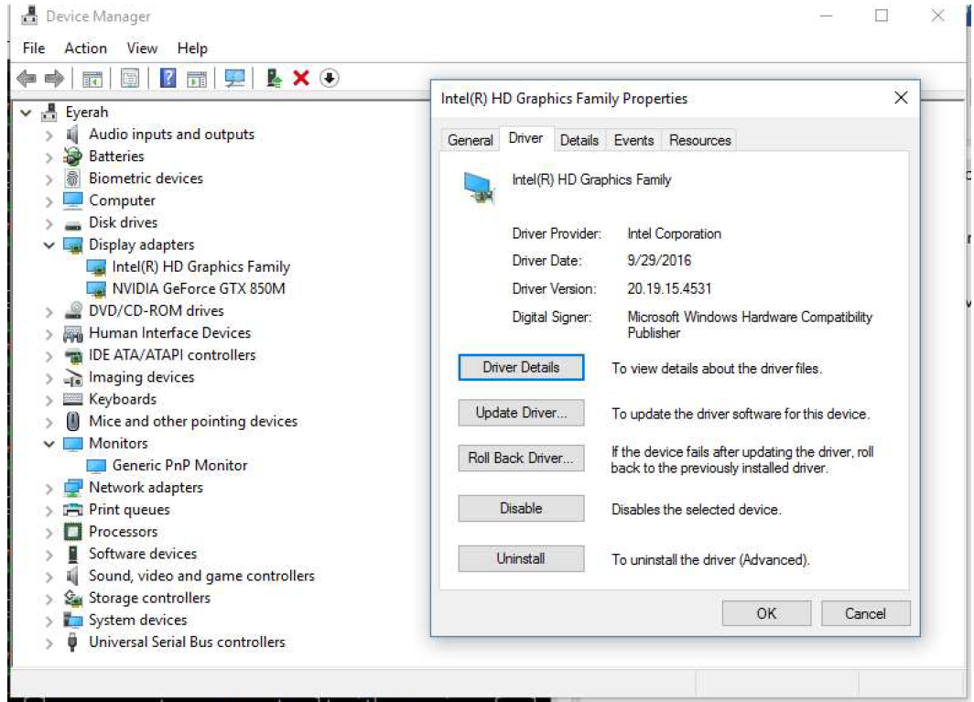
Windows Device Manager
- Next, we will identify how to update software. There are a few options for this. One, is to navigate to the start menu and click the settings button as shown in the picture below.

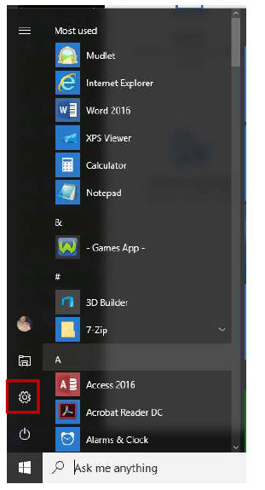

Windows Settings

- (Continued) You will then select the bottom right portion annotated “Update & Security” as shown below.

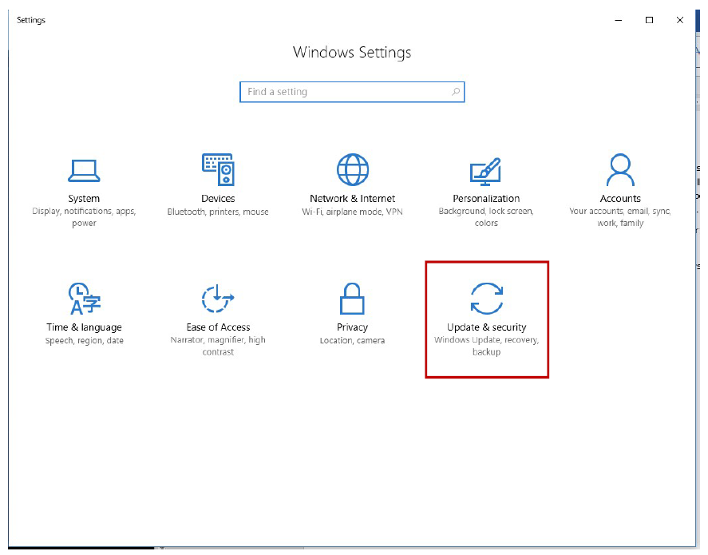
Windows Update & Security Settings
- (Continued) Once in this section, you simply hit “Check for Updates” and Windows will automatically update.

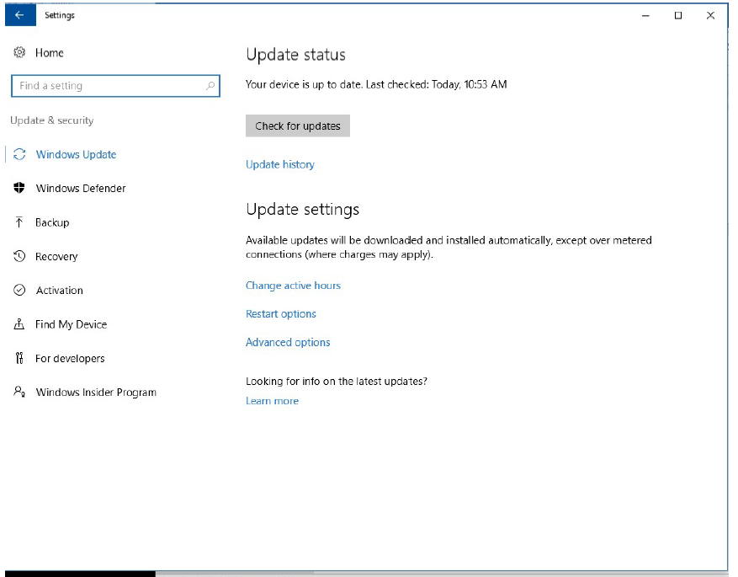
Windows “Check for Updates”

- Following the installation and checking for updates you will need to active your windows. You have typically 30 days before providing a key to Microsoft to verify your genuine copy of windows. To activate your windows, click the start menu and select the “settings” icon as indicated below.

Windows Settings

- Next, you will want to re-enter the “Update & Security” portion. Once in this portion you will then select the “Activate” tab on the left-hand side as indicated in the below image.

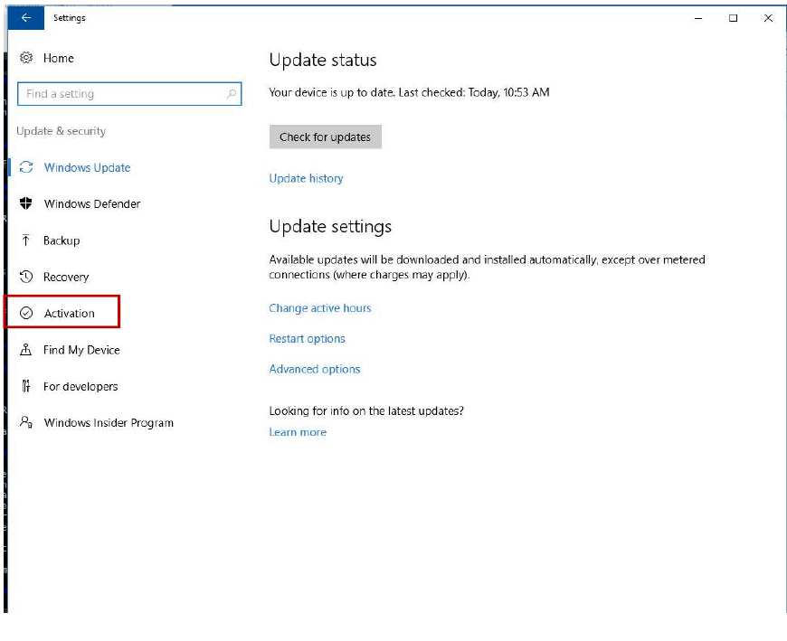
Windows Activation Tab
- Once you have activated the Windows copy you will be finally complete with the full installation of the computer system.

This completes Part III of the PC manual.

References:
- TestOut PC Pro. TestOut (Online). Derived from: Http://ww.testout.com

